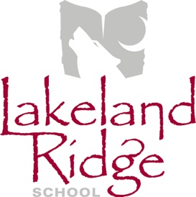
School Council Meeting Agenda
March 12, 2019
6:30 p.m.
Lakeland Ridge School Library

- Opening remarks and welcome April Childs
- Round table introductions All
- Agenda amendments and approval April Childs
- Approval of last meeting minutes April Childs
- Reports
  - EIPS Board Trustee Annette Hubick
  - Administration Report Jeff Huculak
    - Staffing Update
    - Enrolment/Grade Configuration
    - School Fees and Field Trips
    - Library Redesign
  - Mental Health Capacity Building Erin Dawson-Meyers

- Old Business
  - Family Dance Update April Childs
  - Community Building for 2019-20 School Year April Childs

- New Business
- Next Meeting – Tuesday, April 9, 2019

- Adjournment

