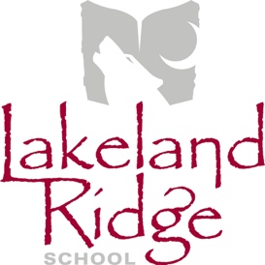
School Council Meeting Agenda
February 12, 2019
6:30 p.m.
Lakeland Ridge School Library

- Opening remarks and welcome April Childs
- Round table introductions All
- Principal Introduction (Power Point) Jeff Huculak
- Agenda amendments and approval April Childs
- Approval of last meeting minutes April Childs
- Reports
  - EIPS Board Trustee Annette Hubick
  - Administration Report LLR Admin Team
  - PAS Report PAS representative
  - Mental Health Capacity Building Erin Dawson-Meyers
  - COSC Report April Childs

- Old Business
  - Returning Student Registration Jeff Huculak
  - New K-4 Curriculum Jeff Huculak
  - Family Dance (Tent. Dates April 6 or 12) April Childs
  - Community Building for 2019-20 School Year April Childs

- New Business
  - School Fees Jeff Huculak

- Next Meeting – Tuesday, March 12, 2019

- Adjournment

